Data Analysis
PHIL 3097 Big Data, Bigger Questions
Spring 2018

ABSTRACT 3
INTRODUCTION 3
PROCEDURE 6
Representation 8
DATA & VISUALIZATIONS 9
Graph 1: Gender and difficulty maintaining honors requirements 8
Graph 2: Class conflicts by college 9
Graph 3: Percentage of Transfer and Freshman Students and their Understanding of a Global Citizen Scholar 10
Graph 4: Gender and satisfaction with the UHP 11
Graph 5: Transition vs. Freshmen and honors help developing them into global citizen scholars 12
Graph 6: Transition vs. Freshman satisfaction with honors 13
Graph 7: Global citizen scholars and satisfaction with advisor 14
Graph 8: Average Satisfaction by College 15
Graph 9: Year and difficulty maintaining honors status 16
Graph 10: Preferences for Increased Offerings by College 17
Graph 11: Preference for Increased Offerings by Year 18
Graph 12: Number of Students using Honors Resources 19
Graph 13: Average Satisfaction by Services Used 20
Table 14: Representation of Survey and Seminar Data by College 21
Graph 15: Do you know what Global Citizen Scholar is, by college 22
Graph 16: BoK Analysis: needs breakdown? 23
Graph 17: Relative Frequencies of Seminars Offers by BoK vs. University Required BoK 24
Graph 18: BoK’s Required vs. Taken for CEAS 25
RECOMMENDATIONS 26
Goal: Increased enrollment/participation in seminars. 26
Goal: Increase retention, aligning activities with mission statement, perhaps satisfaction. 26
Goal: Satisfaction 26
Appendices 27
Survey questions 27
Percent of class slots by subject 27
Whatever else you find. 27

ABSTRACT

We in the PHIL 3097 “Big Data” class were tasked with analyzing data connected to the activities and interests of the University Honors Program with the goal of making recommendations to its administrators to better serve its constituency: the students of the University Honors Program. Based on data from the registrar (and collected for us by Jason Autry), the UHP website, and a student survey that we created, we propose recommendations in the following categories: increasing enrollment in seminars; increasing retention in the University Honors Program; aligning student accomplishments with stated goals; and increasing overall student satisfaction.

INTRODUCTION
The University Honors Program (UHP) at the University of Cincinnati is an entity that represents the interests and promotes the development of its brightest and most ambitious students. In order to be able to properly assist the UHP, we first needed to understand the program, its facts and criteria, its operational statistics, and its ultimate goals. To do this, we first examined the information available about the UHP on its website. Then, we held a meeting with Debbie Brawn, the administrative director of the UHP, during which she described the role of the UHP further and provided us with valuable insight into the goals of the program. Finally, we synthesized our own conceptions of the goals of the UHP and the insight we received from Debbie to propose our ideas of some of the short- and long-term goals of the UHP.

UHP Background
The vision of the UHP is "developing students into global citizen scholars who lead innovative efforts toward solving the world's complex problems." Like most organizations, the vision statement is purposely crafted to be open-ended and broad, allowing each student to determine their own definition of what it means to be a global citizen. This vision then is narrowed, and some operational details of the UHP are provided in the program's mission statement: "The University Honors Program is committed to offering students an individualized, student-centered approach to a meaningful undergraduate experience. To that end, we are dedicated to: Promoting activities that lead students to discover their passions and enhance their gifts and talents; coaching students to purposefully engage in experiential learning opportunities and reflection to maximize and integrate their learning; and fostering a community that prioritizes transformational personal development, civic participation, and global responsibility." With this mission statement, the UHP outlines the actions it takes to help develop students into global citizen scholars (GCS). In addition, the UHP outlines its purpose as follows: "The purpose of the University Honors Program is not to make you do more or work harder because you are an honors student. Rather, it is about finding meaning and gaining deeper learning in what you are already doing. It’s about discovering and diving into your passions. It's about taking risks and trying new things inside and outside the classroom. It's about applying your knowledge and skills in real-world setting. Finally, it's about transformation – academically, professionally, and personally." In combination, this vision, mission, and purpose highlight that which the UHP strives to achieve with its students and its reasons for doing so. In concrete terms, this means that students are challenged in the UHP through seminars and experiential learning projects which focus on community engagement, creativity, global studies, leadership, and research in order to help students become "global citizen scholars."
In order to carry out the UHP’s vision and provide "transformational education," the program also performs the following functions: recruiting students; offering research opportunities; providing recognition to students; providing leadership opportunities and promoting students for nationally competitive awards; hosting seminars, networking events and advising events to assist students in building their personal and professional lives; and offering students priority registration, honors housing, grant funding and social events. To graduate from the University Honors Program and take advantage of its benefits while enrolled, students must fulfill the following requirements: take the Gateway to University Honors course, complete 5 honors experiences (combination of seminars or experiential learning projects), maintain an updated learning portfolio, meet when mandated with honors advisors, and maintain a minimum 3.2 GPA. These requirements attempt to ensure that students participate wholly and reap the benefits provided by the UHP.
In summary, the UHP at the University of Cincinnati is unlike many honors programs or colleges across the nation, because it focuses on enhancing the learning experience of students with the specific purpose of developing global citizen scholars, and it does not simply wish to push the brightest students academically through challenging courses.
UHP Summary Statistics
An integral part of understanding the University Honors Program is recognizing its makeup. We thought it important to examine some summary statistics about Honors students that the UHP freely provides in order to better understand its constituency, and those statistics are as follows.
The University Honors Program is made up of the top 7% of UC undergraduate students. To maintain this standard, the UHP in the last few academic years has tended to accept approximately 350 freshmen students. In 2017, for example, 1,500 incoming freshman were invited to matriculate into the UHP, and 355 students enrolled in UC and accepted its invitation, out of the 34,187 total students who were admitted into the University. The average composite ACT score of these freshmen students in 2017 was a 33, with the 75% quartile achieving a score of 34. There were also a total of 119 students who transferred into the University Honors Program. Of course, the entire population of Honors students is widely distributed across UC's campus. The three colleges with the largest UHP population -- CEAS, A&S, and LCB -- comprised 30.5%, 19.3%, and 16.2% of UHP students, respectively.
The UHP also provides data about the demographics of its students. In 2017, 72% of its 1,463 total students were Non-Hispanic/White; 3% were Black; 3% were Hispanic; 7% were Asian; and 4% were multiracial. In addition, international students who are members of the UHP come from many different countries, including Bangladesh, China, Egypt, Haiti, India, Indonesia, Myanmar, Nigeria, Singapore, Russia, Vietnam, Ukraine, and many others. Study abroad opportunities are popular among UHP students, as well. In 2017, 71% of UHP graduates had studied abroad at least once, and 50 countries were visited by its students.
Goals of the UHP
The University Honors Program aims to aid students in shaping their identity and development through multiple assets that the program offers. The program intends to enrich the education of its students through increased opportunities for community engagement, creativity, global studies, leadership, and research. The honors program does not wish to increase the number of incoming students per year, as this would create a strain on resources and, potentially, diminish the quality of service provided to its current students. However, the UHP does wish to increase the retention rate of its students throughout the duration of each student’s tenure in the program so that they may more successfully fulfill their mission of offering students an individualized approach to a meaningful undergraduate experience. The program also aims to promote activities that lead students to discover their passions and enhance their gifts and talents. To achieve these goals, the UHP makes conscious efforts to encourage students to engage in experiential learning opportunities and then reflect meaningfully, such that the UHP might foster a community that prioritizes transformational personal development, civic participation, and global responsibility. The purpose of this report is to analyze data in such a way that allows them to achieve these goals more effectively, efficiently, and, hopefully, with increased retention of students.

PROCEDURE

Data Gathering
We began by examining general information on the UHP, such as its mission, purpose, and student benefits. In order to verify our take on the UHP, we presented our initial information to individuals from the administration. We then received data from the UHP and collected course information from the UHP website. We also created and refined a survey to collect more data about honors students, such as major and satisfaction with the program. We sent the 15 question survey to all honors students through the UHP listserv to gather more information and background not provided in the original data set.

Data Cleanup
After gathering the data, we cleaned it up for easier interpretation. To start, the BoK (Breadth of Knowledge) codes were reorganized to clearly express which classes had which BoK codes and the data sheet was checked for spelling errors or inconsistencies (electrical engineering vs. Electrical Engineering). Professor names were also added to the data sheet, retrieved from the UHP website. The class names were sifted through to ensure no classes were double counted or too similar to other classes(same class with a slightly different name). Classes under the latter situation were marked for further review. In the data sheet, UC enrollment and class registration of the same student were on different lines, so these lines were combined for clarity.

Data Interpretation
We organized data regarding honors seminar days and times to explore which times are most popular. To do so, we plotted the number of students who enrolled in honors seminars by each day and start time. From this plot, we can see trends in enrollment by time for each day. For example, both Tuesdays and Thursdays experience high enrollment in mid-afternoon courses.
We encountered a problem in our attempts to determine the most popular days and times for students to take honors seminar: date labels for Tuesdays and Thursdays were sometimes ambiguous. For example, the abbreviation “TR” may refer to classes that take place both Tuesday and Thursday, or may refer to just Thursday classes. To solve this problem, we compared the length of classes for ambiguously designated courses to the length of courses with clear designation. From this information, we could determine that courses designated “TR” likely took place on Tuesdays and Thursdays (since they were all one and a half hours long), while courses designated “TH” were likely only on Thursdays (since they were generally three hours long).

BoK Codes
We also analyzed which BoK codes were most popular overall and by academic program. This data was then compared with the total University of Cincinnati BoK requirements to show the relation between what seminars were offered and what seminars students needed to take. Drilling down to college-level and major-level BoK requirements proved too cumbersome, so we used University-level requirements as proxies. A possible expansion of this study would include a finer-grained analysis of BoK requirements by college and major and compare them to the actual UHP courses taken by member of those colleges/majors.

Survey
We also created, conducted, and analyzed a survey. We received 420 responses, which was more than we originally expected. Nearly 64% of respondents were female while 36% were male. The plurality of respondents were freshman at the University of Cincinnati. Many of the respondents were from the College of Engineering and Applied Science (CEAS) or the McMicken College of Arts and Sciences(A&S). We created a pivot table to compare gender, year, major, satisfaction, and whether students transitioned into the UHP or were accepted as a freshman. We then looked at gender, satisfaction with the honors college, and difficulty maintaining honors status.
Based on the pivot table we created we were able to compare the characteristics and find the correlations or lack of. Transition students are also more satisfied with the UHP. Men appear to be less satisfied with their honors advisors and the UHP. CCM and CEAS have the lowest understanding of what a GCS is while A&S and the College of Medicine have the greatest understanding. Interest in study abroad decreases by year. The requirements become more difficult as students progress through the years. People who claim to know what a GCS is are happier with their advisors and in the honors program. All CCM students entered the honors program as freshmen. Some of these finding are analyzed in more detail below.

Time Slots
We counted how many people were enrolled every 5 minutes between 8am and 9pm. We then organized that by day and created charts to display actual enrollment vs. enrollment cap. Enrollment cap is based on an estimated 20 people per class. For example, if there are 10 classes offered at noon on Thursday, the enrollment cap would be 200 for that time.
Mondays and Wednesdays are the busiest days with the most classes taken and offered. Peak enrollment ratio (88%) on Tuesdays and Thursdays occurred at 1pm which leads us to believe that more classes should be offered at those times to accommodate interest. Fridays have many available classes offered in the afternoon, yet enrollment is higher in the mornings. Friday 9-11am class enrollment ranges from 95-100% of possible enrollment space filled. We speculate this is because students like to have a “short” Friday. There are no classes offered on Tuesdays or Thursdays from 8am to 9:30 am or after 3:25 pm on Fridays. Average enrollment ratio across all days stays at approximately 48%. All other trends are as expected and follow enrollment cap.

Representation
The relative participation in our survey by college is listed in Table 14, as are the participation rates in honors seminars. Some colleges have more or fewer students than expected enrolled in honors seminars, or variation from the expected participation in the survey. This is important to note when analyzing the data presented, because colleges, and therefore different types of students, are not necessarily represented proportionally in the results. Additional explanation is provided under Table 14.

DATA & VISUALIZATIONS

Data Visualizations

Graph 1: Gender and difficulty maintaining honors requirements

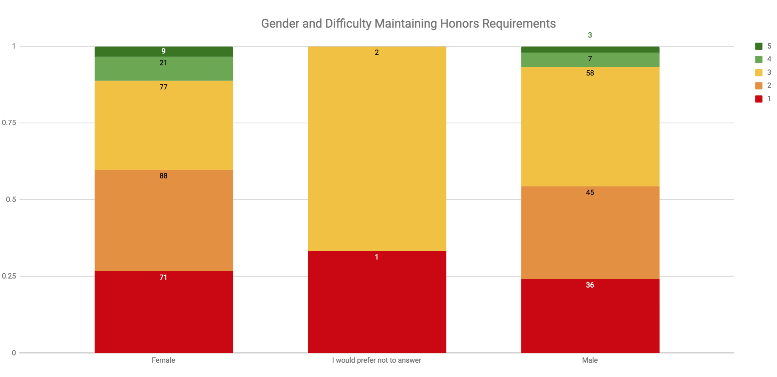
Graph 1, above, details the breakdown by gender of difficulty in maintaining the honors requirements (# of experiences, meetings, etc.). This data was gathered via the survey that was sent out to all of the honors students. Unfortunately, it proved to be inconclusive in terms of generating an actionable correlation on its own. The average score for males surveyed was 2.302 and the average score for females surveyed was 2.282 with standard deviations of 0.953 and 1.047 respectively. It is observed however, that females tend to be on the extremes of the spectrum. A satisfaction level of 3 is the only number in which the proportion of males surveyed is larger than the proportion of females surveyed. These observations help to explain why the standard deviation for females surveyed was higher than it was for males. Given that the difference in average score was not very large it would appear that there is no direct correlation between gender and difficulty maintaining honors requirements. The only action that could be drawn from this data is to attempt to offer some sort of service or push existing ones that can help improve satisfaction as a whole.

Graph 2: Class conflicts by college

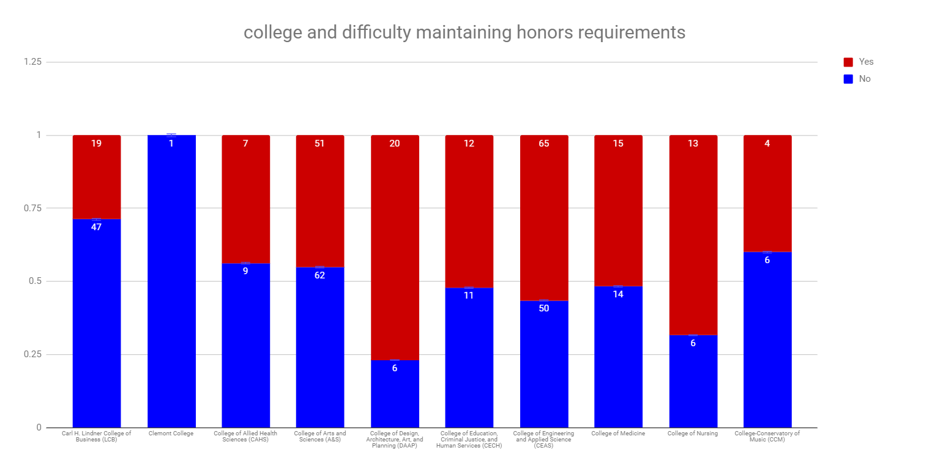
In terms of the class conflicts by college as seen in the chart above, the only colleges that have significantly more Yes’s than No’s reported from the survey are DAAP, CEAS and the College of Nursing. It is also true that these colleges are the most known for their respective extracurricular activities that are required for graduation. CEAS and DAAP students participate in Co-op, and Nursing students have clinicals. These colleges also may have more strict times blocked off for certain courses. This graph demonstrates that many students do have interest in taking seminars, but scheduling conflicts frustrate those desires. This should be taken into account when assigning class times to to honors seminars.
Interestingly, survey data show that students in these high-conflict colleges do not have a strong preference for increased seminar offerings (see Graph 10). One possible explanation for this is that students feel that they may not be able to take honors seminars even if they were offered at convenient times, due to rigorous coursework or other time-consuming activities. Further study of this issue is necessary: would students with high time-conflict prefer flexible activities? Would they prefer non-seminar activities more generally?

Graph 3: Percentage of Transfer and Freshman Students and their Understanding of a Global Citizen Scholar
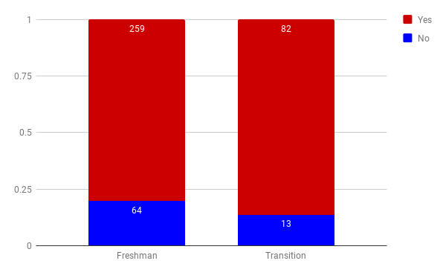
Based off the data collected in the survey, transfer students believe they have a greater understanding of what a global citizen scholar id as opposed to freshman students. This may be because incoming freshman accepted into the honors program may have no knowledge of the UHP beforehand, whereas transfer students express interest and must apply to get into the UHP, which means they most likely have done extra research on the UHP and its values. Transfer students may also better understand the impact that being in the honors program would have on them. Information in subsequent graphs about students’ understanding of “Global Citizen Scholar” is relevant to interpreting this result. Although there is no significant difference in understanding in this case alone, we found that student are more exposed to introductory activities within the honors college tend to report higher understanding of “Global Citizen Scholar.” Recommendation concerning this are below.

Graph 4: Gender and satisfaction with the UHP
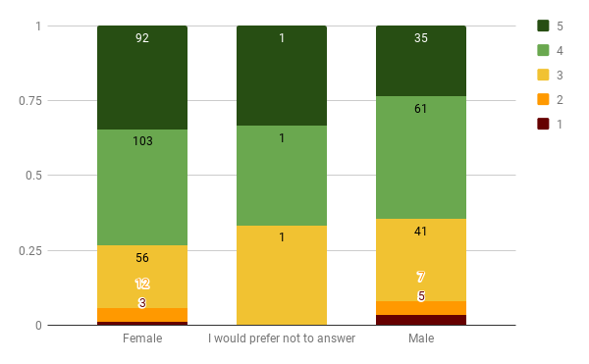
Based on the survey question, which asked each respondent to rank his/her satisfaction with the Honors Program, the graph shown above was developed based on correlation with the respondent’s provided gender. The graph shows the quantity of respondents for each gender who indicated his/her specific level of satisfaction as well as normalizes the data for comparison across genders.
From this specific correlation between gender and satisfaction, it is found from the set of survey respondents, that females seem to be overall more satisfied than males (less unsatisfied and more satisfied females percent-wise) with the UHP. This, despite the fact that females had marginally more difficulty fulfilling requirements (see Graph 1), based on percentage of responses in the 4-5 difficulty range. This same type of cross-graph analysis could be conducted by comparing gender response’s with other survey results such as class conflicts, resource utilization, number of experiences, and satisfaction with advisor to potentially understand some reasons as to why the overall satisfaction disparity with regards to gender exists. The additional satisfaction correlations developed (as shown in other graphs, i.e Graph 6) suggest that gender is not the only criteria for which satisfaction differs only slightly amongst groups of respondents. This leads to a question of whether the conclusion that women in the UHP are slightly more happier than men in the UHP is a correlation that the honors college should investigate further. Like the potential additional gender correlations listed above, many other survey questions could be analyzed in comparison to overall satisfaction in order to try and understand what truly drives satisfaction among UHP students. The first correlation that may be worth investigating further is the gender breakup of colleges and how that relates to satisfaction.

Graph 5: Transition vs. Freshmen and Respective Satisfaction with the UHP
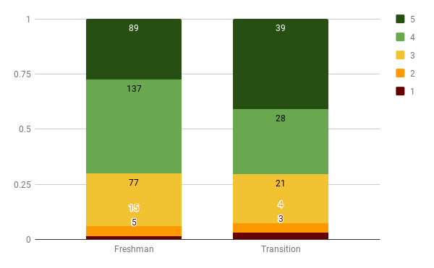
This graph represents the responses received from the survey concerning the difference in satisfaction with the UHP between students entering the program as Freshmen versus those that entered later as transfer students. The average satisfaction levels amongst Freshmen and Transition Students are 3.898 and 4.011 respectively. Given how high the sample size is, this difference is worth noting. This can most likely be accounted for based on the presumption that Transition Students have probably spent more time researching and trying to understand the UHP prior to acceptance than students that were accepted into the program immediately. Based on these findings, we would suggest that the UHP attempts to instill in Freshmen the benefits and values that the UHP offers, given that the resources available to them have been utilized. It is worth noting, however, that the UHP has somewhat reformed its Introduction to the UHP course, so over the next few years we may find a gradual increase in the average satisfaction level of students that entered the UHP a Freshman.

Graph 6: Transition vs. Freshman satisfaction with honors

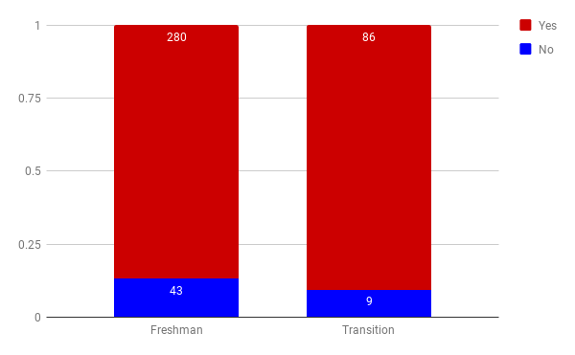
Graph 6 shows that a higher proportion of transition students are satisfied with the UHP than that of freshmen. This gap is possibly due to different expectations from freshman and transition students. Transition students as shown in prior charts appear to have a better understanding of UHP due to the application process. This varying experience would likely be enough to cause a slight difference in satisfaction with the honors program.
This data relates to two other graphs. In Graph 3, transition students believe they have a better understanding than freshman of what a global citizen scholar is. In Graph 5, more transition students than freshman felt the UHP helped them develop into global citizen scholars. It should also be kept in mind that there are more freshman than transition students in the honors program.

Graph 7: Global citizen scholars and satisfaction with advisor
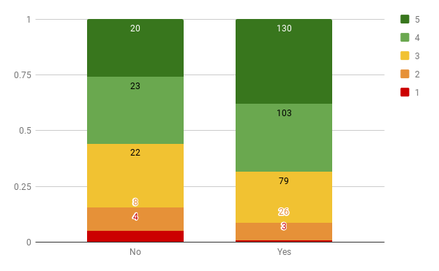
A larger percentage of the people who considered themselves global citizen scholars stated that they are happier overall with their advisors compared with those who said they do not consider themselves global citizen scholars. This indicates a positively trending correlation between these two parameters. However, it is worth considering that there are other contributions to a student feeling like they are a global citizen scholar. Satisfaction with the honors advisor should not be treated as the sole cause of this, but it can be a contributing factor.

Graph 8: Average Satisfaction by College
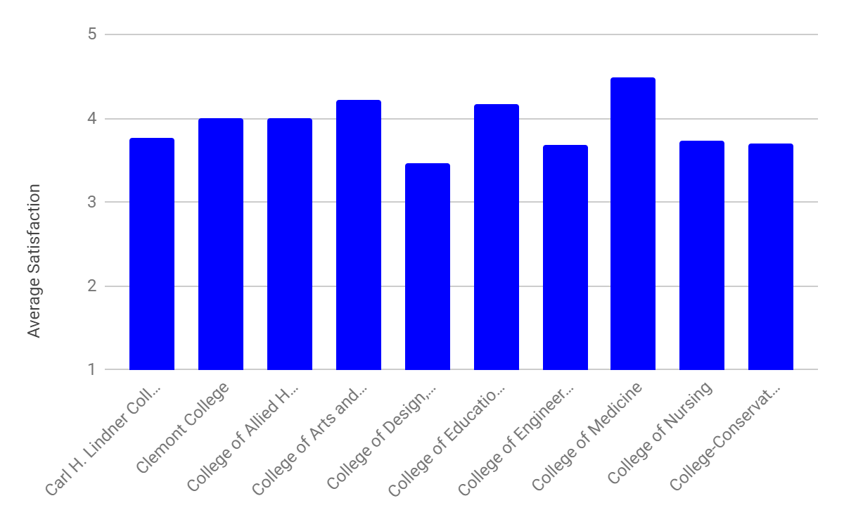
This graph compares satisfaction by college at the University. When comparing to the students’ self-reported understanding of the definition of a global citizen scholar (GCS), The Carl H. Lindner College of business has a higher understanding but a lower average satisfaction compared to other colleges. This seems to be an outlier as the remaining colleges show the same trend: as the understanding of GCS increases, so does overall satisfaction with the Honors Program.

The average satisfaction among the colleges is generally uniform, with many having been rated about a 4 out of 5. The College of DAAP has the lowest satisfaction and this should definitely be addressed. This graph does not tell us much about the UHP because it is more about the different colleges in general and how satisfied the students are. As stated before, there does seem to be a positive correlation between understanding what a global citizen scholar is and college satisfaction. As seen on Graph 10, DAAP students do not have as many study tour opportunities as the other majors. Perhaps an increase in that would help with the satisfaction and morale of the students.

Graph 9: Year and difficulty maintaining honors status
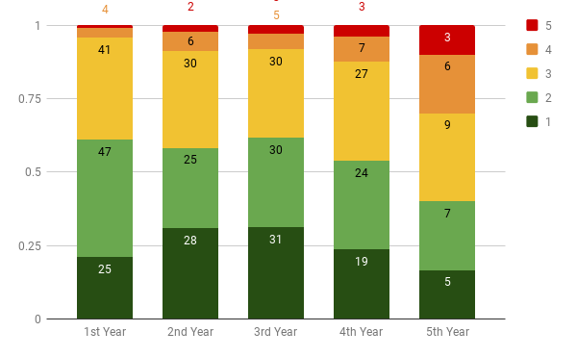
Graph 9 expresses the difficulty in maintaining honors over the course of five years at UC. It shows more students have a harder time maintaining honors requirements as they progress through school. From the first to fourth year, more than half of the students found maintaining honors requirements relatively easy, however that number drops off for fifth-year students.
To help ease the difficulty, adding more opportunities in seminars and pre-approved experiences, as expressed by the students in Graph 10, would provide them with more options to fulfill the required five experiences. Graph 2 also expresses the class conflicts per college and the challenges that come with fulfilling experiences while also taking major-specific courses.
This chart does not consider GPA, which might be a lurking variable in this system. Also, the increase in difficulty for fifth-year students may be confounded by the colleges of these students. That is, the bulk of fifth-year students are enrolled in colleges that require co-op and have traditionally more strenuous coursework. Students in these colleges may have more difficulty overall, so more analysis is needed to determine if the rise in difficulty over time holds when controlling for college.

Graph 10: Preference for Increased Offerings by College
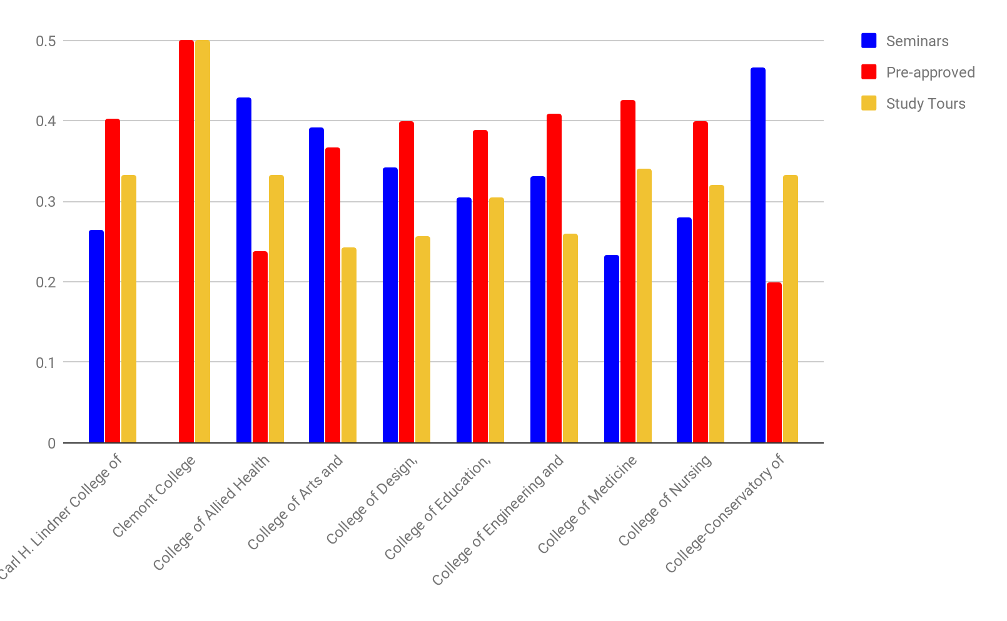
This graph shows the percentage of students in each college who say that they would like to see more of three different types of honors experiences: seminars, pre-approved experiences, and study tours. This may provide insight into what content may be most popular for each type of experience. For example, Graph 11 shows the percent requests per year. The connection between the two graphs may help shape what type of experiences are offered to and in what subject area. For instance, more pre-approved experience could be offered to those in DAAP, CECH, CEAS, and College of medicine. Where as study tours could be aimed at first year students in the College of Business, CAHS, College of Medicine, and CCM. Through the utilization of graphs 10 and 11, you can help tailor the honors experiences to students interests to get the most involvement and satisfaction from honors students.

Graph 11: Preference for Increased Offerings by Year
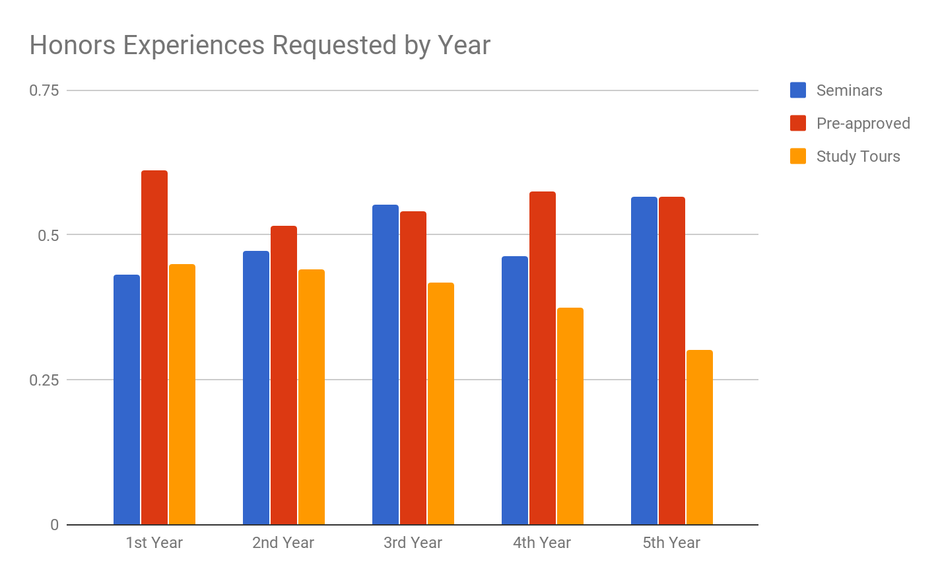
Graph 11 shows how students responded when asked which experiences they would like more of, organized by their year of college. Students could select multiple options and the bars in the graph represent the percentage of participants that selected each option. Though more than 50% of students at each year requested more pre-approved experiences, we see earlier students requesting more study tours and more senior students requesting more seminars. One possible takeaway from this data is that it may help students to advertise these experiences by year. Mainly, advertise study tours to first and second year students and advertise seminars to third, fourth, and fifth year students.

Graph 12: Number of Students using Honors Resources
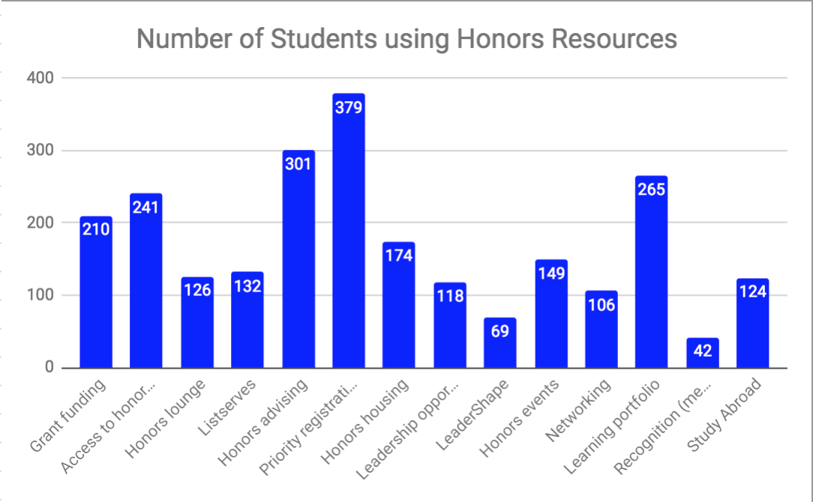
This graph displays how many UC students utilize each resource offered by the Honors College. From this chart it is clear that most Honors students take advantage of honors advising and priority registration. Furthermore, recognition, networking, and LeaderShape are the resources that are the least taken advantage of. This implies that the Honors college may need to improve on the quality of -- or how they advertise -- these lesser used resources. As some of these resources are mandatory to use, such as the learning portfolio, the amount of students that use them may be artificially inflated.

Graph 13: Average Satisfaction by Services Used
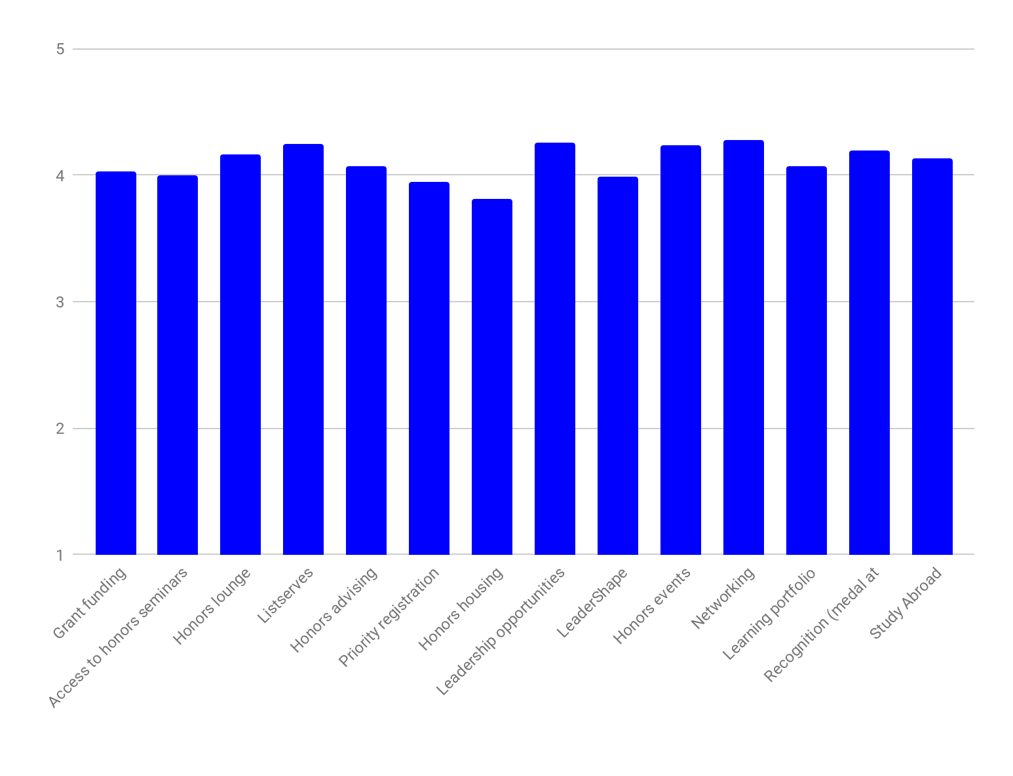
This graph shows average satisfaction among students who said they used each service. This may be useful in understanding the value students place on certain activities, and which services correlate with higher satisfaction. For example, those who have leadership or networking experience within the UHP tend to have higher levels of satisfaction.

Table 14: Representation of Survey and Seminar Data by College

College | Actual Enrollment | Seminar Enrollment | % Error from Actual | Survey Response | % Error from Actual
CAHS | 3.51% | 4.34% | 23.37% | 4.12% | 17.35%
A&S | 20.64% | 34.72% | 68.19% | 29.12% | 41.07%
LCB | 17.35% | 10.56% | -39.11% | 17.01% | -1.96%
CEAS | 32.65% | 29.17% | -10.67% | 29.64% | -9.22%
DAAP | 13.76% | 8.42% | -38.84% | 6.70% | -51.31%
CECH | 4.61% | 5.05% | 9.51% | 5.93% | 28.53%
NUR | 4.32% | 4.76% | 10.11% | 4.90% | 13.38%
CCM | 3.15% | 2.99% | -5.07% | 2.58% | -18.13%
This table shows the relative representation of students from each college in our survey and seminar data. It compares the proportion of UHP students enrolled in each college to the proportion of students who took seminars or filled out our survey. In both cases, there is wide variation in participation among colleges. Students enrolled in the College of Arts and Sciences, for example, represent 68% more seminar enrollees than their overall population would have suggested. Similarly, DAAP students were highly underrepresented in our survey data. This table could suggest differences in engagement among colleges.

Graph 15: Do you know what Global Citizen Scholar is, by College
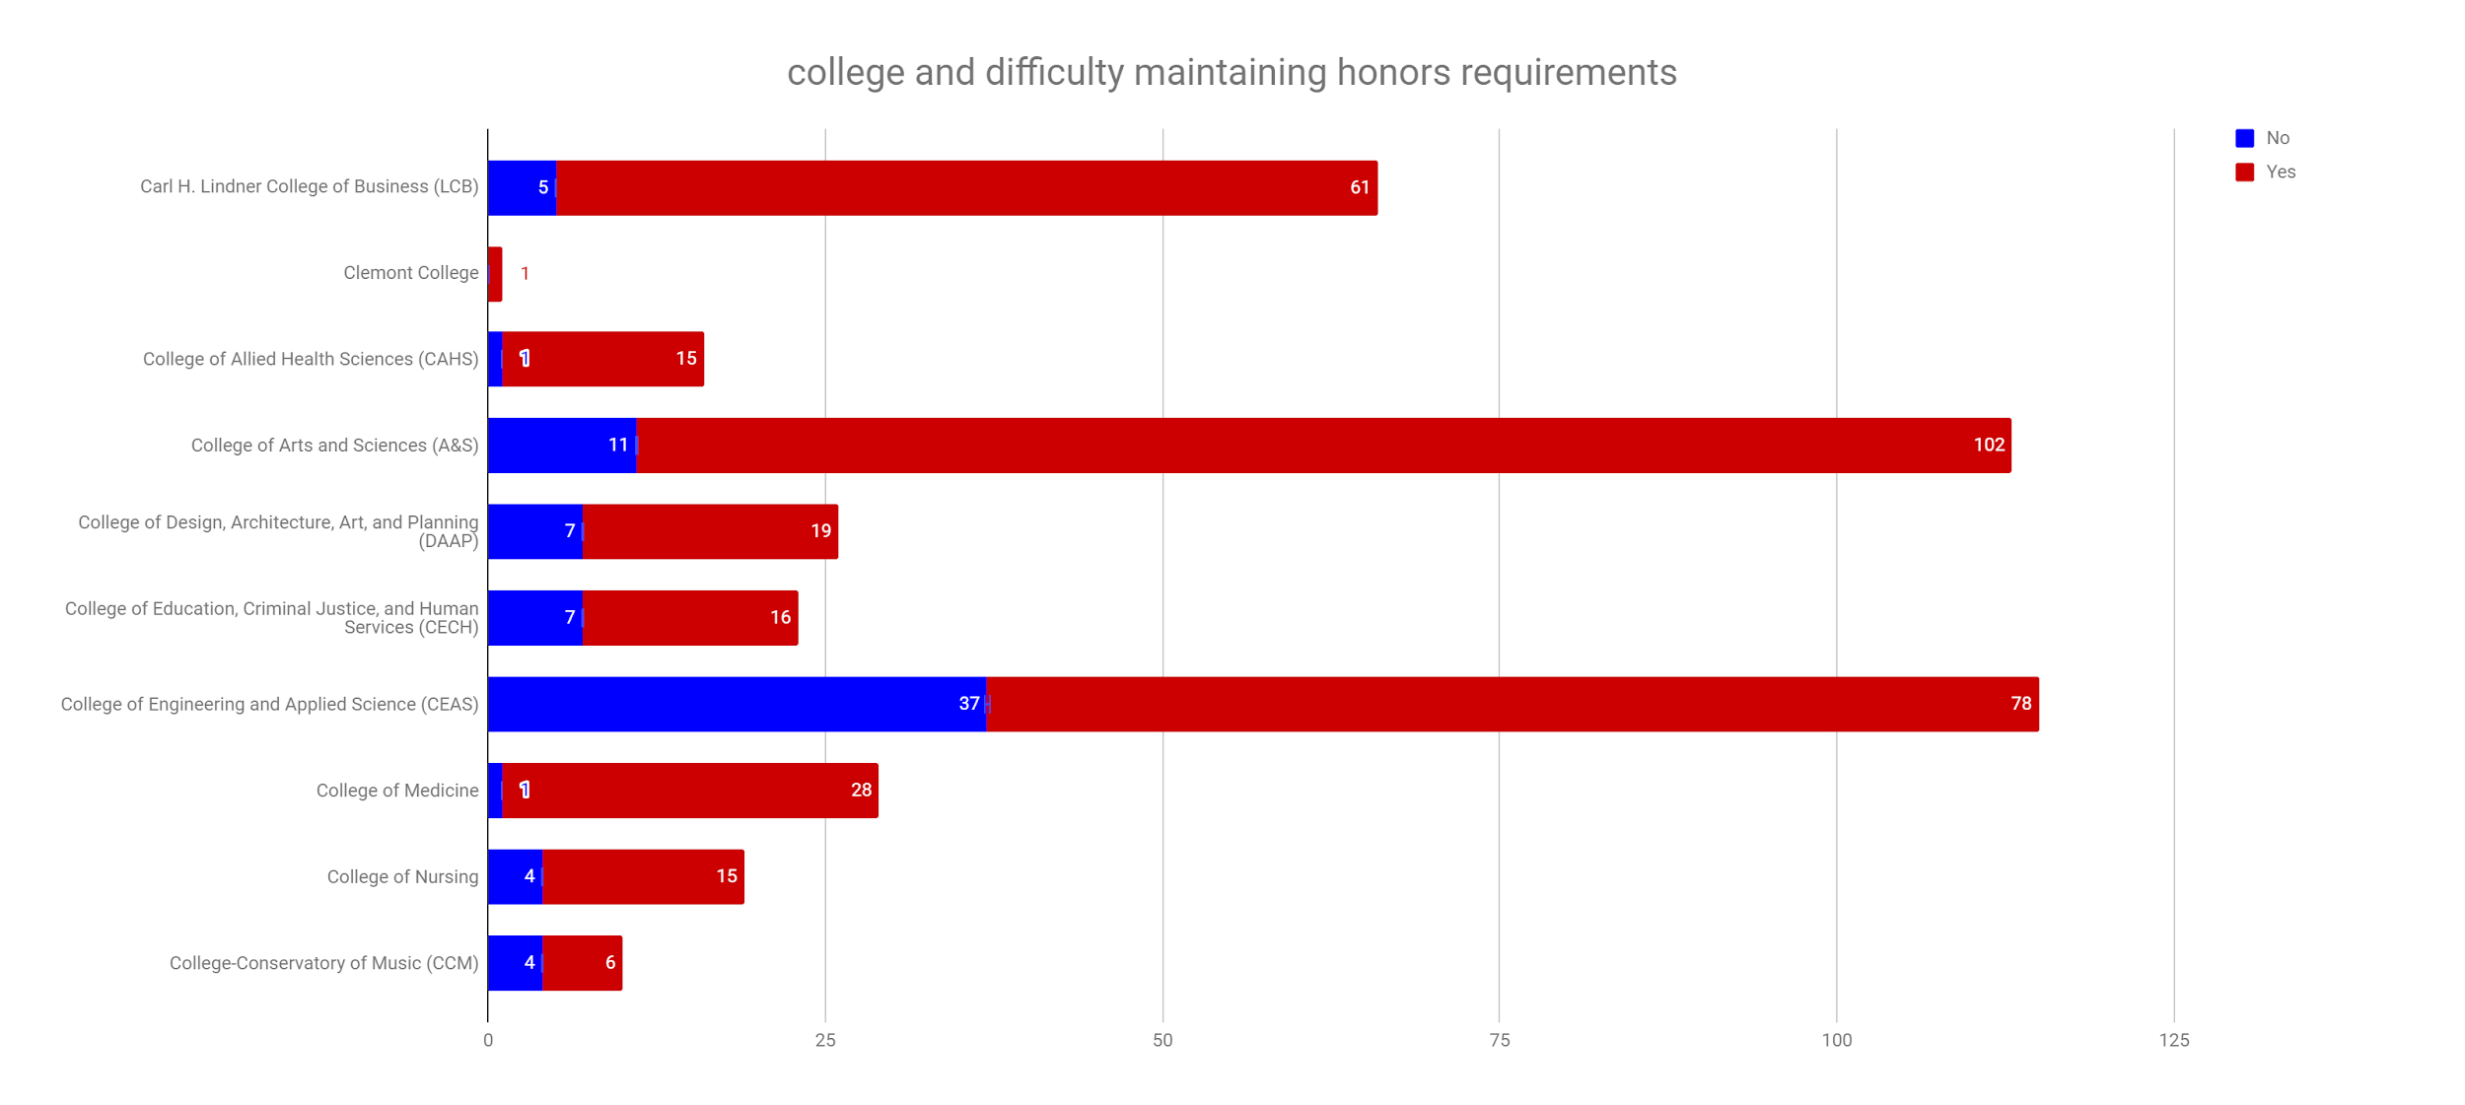
This graph represents survey data that was collected on students evaluation of whether or not they understand what it means to be a “global citizen scholar” or GCS. One of the UHP’s goals is to help students become GCSs so it is important to understand what the term means.
The College of Engineering and Applied Science had the greatest number of people not know what a global citizen scholar is. The College of Conservatory of Music had the greatest proportion of people who believed they do not understand what a global citizen scholar is, but they also make up one of the smallest portions of the honors college at just 3.15%. CCM survey representation was even lower at 2.58% which could cause the ‘no’ responses to appear more impactful. CCM satisfaction is average as shown in graph 8, despite the lack of knowledge about GCS. The College of Medicine, The College of Allied Health and Sciences, and The College of Business had the greatest number of people who believed they had an understanding of what a global citizen scholar is.

Graph 16: BoK Analysis: needs breakdown?
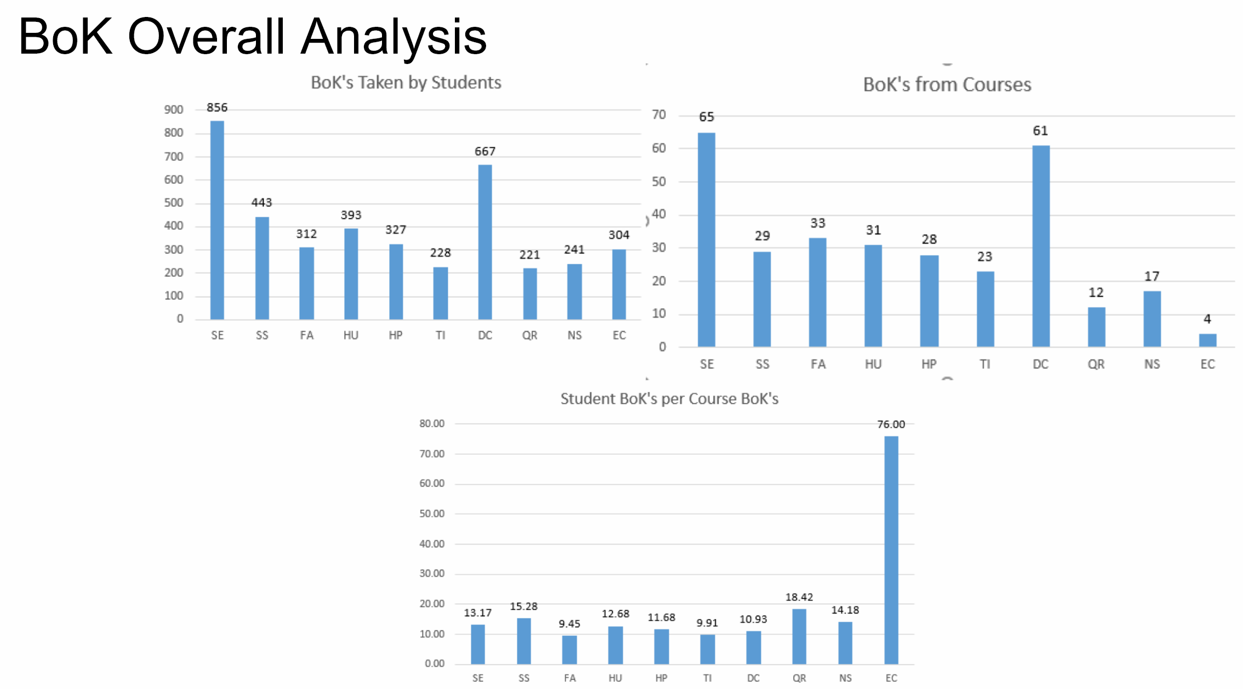

These graphs represent the BoK data that we received from Jason Autry’s data. These graphs show the breakdown of what Breadth of Knowledge (BoK) codes students take versus what BoKs are offered. The bars on the first chart are how many students took classes with the given BoK codes. The second chart shows how many courses are offered with the BoK codes attached to them. The bars on the third chart represent the ratio of the first two charts. The ratio is the number of BoK’s taken by students by the number of BoK’s offered by courses. From the third chart, it can be observed that the average class is around 16 students with the outliers being English Composition (EC), with more than 3 times the amount of students. Fine Arts courses have the lowest ratio of students per class with that BoK code.

Graph 17: Relative Frequencies of Seminars Offers by BoK vs. University Required BoK

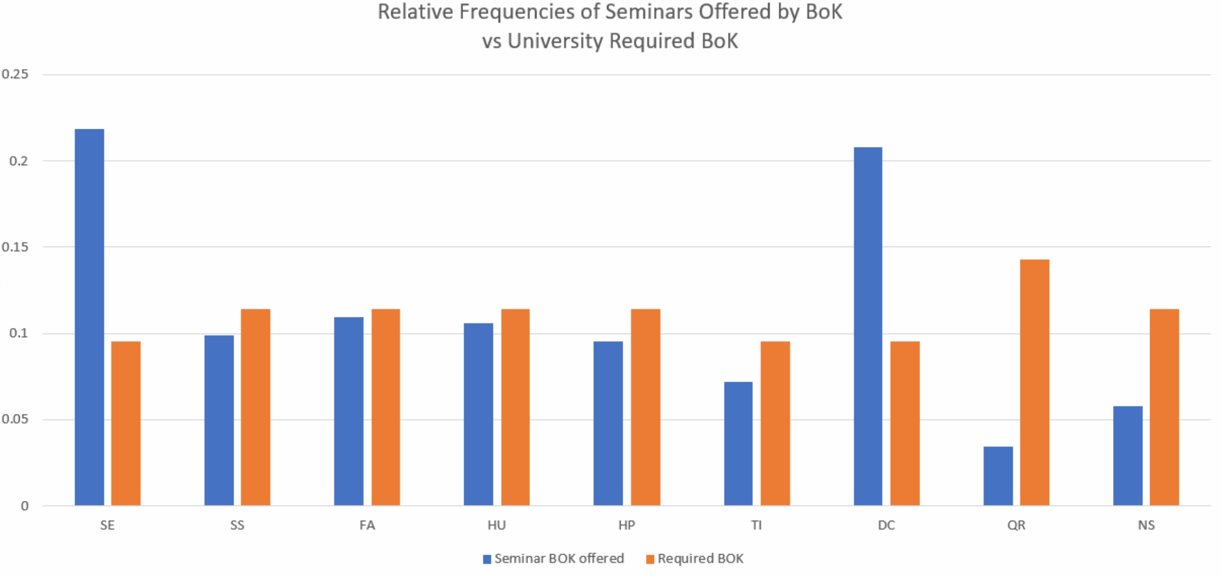

This graph illustrates the BoK courses that students are taking vs the University’s number of required BoK codes. The EC (English Composition) attribute can be ignored since its ratio is an outlier due to some Honors English Composition courses not having the EC attribute. From these charts we concluded that the Honors college is probably either offering too many DC (Diversity and Culture) courses or that the DC BoK is a very easy code to assign. We also concluded that the Honors College may want to offer more QR courses given that there are only a few QR (Quantitative Reasoning) classes offered yet it has the highest ratio of students per class. This can also be seen in this graph since the proportion of QR codes being taken is significantly lower than what is required by the university.

Graph 18: BoK’s Required vs. Taken for CEAS
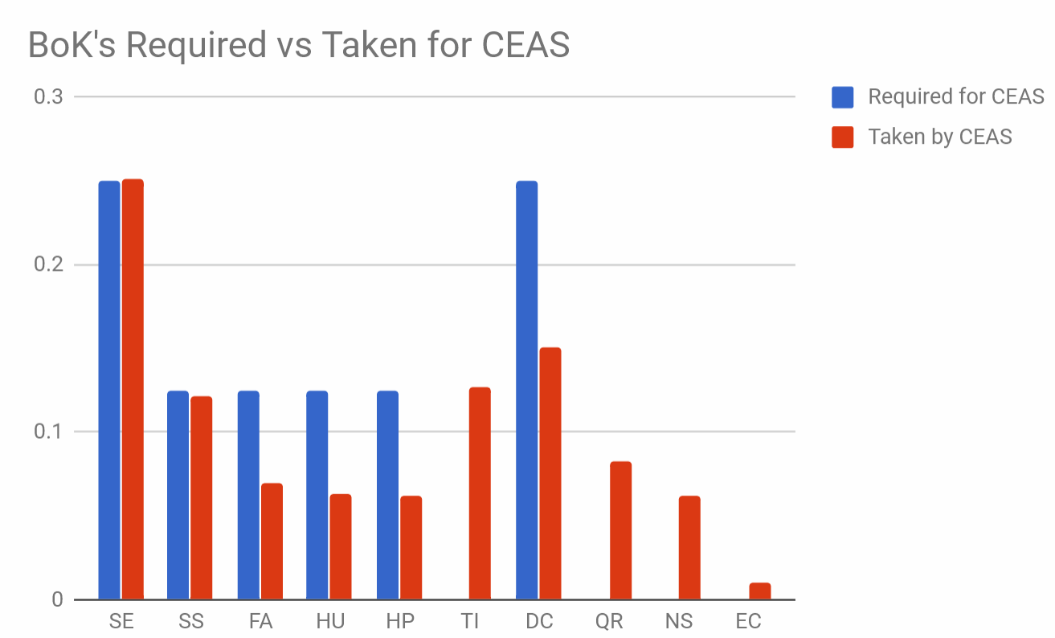
This graph shows that CEAS students are taking several BoK’s that are not required by their major. The fact that TI (Technology and Innovation), QR (Quantitative Reasoning), and NS (Natural Science) Honors seminars are being taken by prospective engineers may imply that students take classes that are related to their major. Honors CEAS students are taking non-Honors classes to fulfill their DC (Diversity and Culture) BoK requirement almost half the time. On the other hand, their SE (Social and Ethics) requirement is almost always satisfied by an Honors Seminar. This could be due to the fact that some CEAS students have a DC credit from high school that will transfer, or there might not be enough DC Honors Seminar offerings that appeal to CEAS students.
Similar graphs can be made for other colleges using these resources, if this type of analysis were to be expanded. For example, this link has BoK data for the College of Arts and Sciences.

RECOMMENDATIONS

Goal: Increase enrollment/participation in seminars.
Mondays and Wednesdays are the busiest days with the most classes taken and offered. Peak enrollment ratio (88%) on Tuesdays and Thursdays occurred at 1pm which leads us to believe that more classes should be offered at those times to accommodate interest. Fridays have many available classes offered in the afternoon, yet enrollment is higher in the mornings. Friday 9-11am class enrollment ranges from 95-100% of possible enrollment space filled. We speculate this is because students like to have a “short” Friday. There are no classes offered on Tuesdays or Thursdays from 8am to 9:30 am or after 3:25 pm on Fridays. Average enrollment ratio across all days stays at approximately 48%. All other trends are as expected and follow enrollment cap.
Students in the colleges of DAAP, CEAS, and nursing may feel hopeless with regard to time conflicts between their required major courses and honors seminars. This is illustrated by the elevated number of class conflicts self-reported by students in these colleges (see Graph 2), as well as the relatively low preference for increased offerings of seminars (see Graph 10).
Our recommendations to remedy this conflict are as follows: 1) form relationships with advisors for affected majors so that existing curriculum requirements can be fulfilled with honors courses, and develop partnerships that allow students to take major courses through the honors program; and 2) consult with high-conflict colleges in particular concerning course and scheduling requirements, and schedule some portion of the UHP seminars around those requirements.
Gearing seminars toward CCM students may be beneficial, and more pre-approved experiences would be appreciated in several colleges, including DAAP, CECH, CEAS, College of Medicine, and College of Nursing. Further analysis of graphs 10 and 11 could help show where and what type of offerings would be most beneficial to honors students. To gain a better understanding of which types of seminars appeal the most to students in each college, it could be beneficial to examine this spreadsheet. It analyzes historical interest in courses by college. So, for example, if a course has traditionally been of interest in CEAS, it would be best to schedule it such a way that it works best with CEAS course scheduling, and it is less important whether it conflict with DAAP requirements.

Goal: Increase retention, aligning activities with mission statement, perhaps satisfaction.
Efforts to establish an understanding of the concept of a Global Citizen Scholar may benefit from more front-loading of the idea in one’s education. Transitioning students (who must learn more about the UHP before they enter than freshmen) report a marginally higher understanding of GCS (see Graph 3). While the difference is small (about 6%), it is worth investigating.

Goal: Satisfaction
Understanding of Global Citizen Scholar is positively correlated (if weakly) with several types of satisfaction. Causality issues aside, it might be worth experimenting with workshops or activities that increase the understanding of GCS and seeing if reports of satisfaction show similar changes.
Graph 4 shows that females are generally more satisfied with the Honors Program than males are. Further analysis of this finding using different metrics (college breakdown by gender, class conflict by gender, etc.) could yield new and revealing correlations that would help explain this discrepancy.
Out of all the colleges, DAAP students seem to have the lowest satisfaction with their college. This should definitely be addressed and more efforts should be taken to increase their satisfaction with UHP and their college. Table 14 shows that DAAP students participated in seminars and surveys at a much lower rate than their proportion would suggest. This may show a lack of engagement in the UHP. As seen on Graph 10, DAAP students would prefer more pre-approved experiences as opposed to other types of activities. Perhaps increasing these would help with the satisfaction and morale of the students.

Appendices

Extra Analysis
Some additional graphs can be found here. They provide supporting information for the results above, but are too detailed to replicate completely.

Survey questions
- What is your gender?
- What year are you at UC?
- What college are you in?
- What major are you?
- Did you enter Honors as a freshman or a transition student?
- How many of the following honors experiences have you completed? (Input number for each)
- Where would you like to see more offerings?
- Do you fully understand what it means to be a global citizen scholar?
- Do you believe Honors has contributed to developing yourself as a global citizen scholar?
- Which of the following benefits have you taken advantage of?
- Have you ever been unable to take an honors course because of a scheduling conflict with a major specific course requirement?
- Have you found the requirements of maintaining honors status challenging? (1- Not Challenging, 5- Very Challenging)
- Are you happy with how often you meet with your honors advisers and your interactions with him/her? (1- Unhappy, 5- Very Happy)
- Rank the following from 1 (most important) to 4 (least important) when deciding to take an honors seminar?
- Are you satisfied with the honors program? (1- Least Satisfied, 5- Most Satisfied)

Who We are
Zvi Biener, Philosophy, Professor
Nick Brubaker, Business Analytics 2019
John D’Alessandro, Computer Science 2019
Mohamed El-Sayed, Mechanical Engineering 2018
Benjamin Gramza, Mathematics 2019
Mitch Isler, Political Science and Economics 2019
Thomas Legeza, Chemical Engineering 2022
Christopher Merz, Mechanical Engineering, 2018
Hardik Modi, Finance and Neuroscience 2019
Thomas Muha, Computer Science 2022
Gregory Tompkins, Finance and Information Systems 2020
Katie Wilburn, Dietetics 2021
Cameron Woods, Mechanical Engineering 2021
Jonathan Turnwald, Electrical Engineering 2022

